- Metastability is a phenomenon that can cause system failure in digital devices, including FPGAs, when a signal is transferred between circuitry in unrelated or asynchronous clock domains.

- Metastability problems commonly occur when a signal is transferred between circuitry in unrelated or asynchronous clock domains
- The likelihood that a register enters a metastable state and the time required to return to a stable state vary depending on the process technology used to manufacture the device and on the operating conditions. In most cases, registers will quickly return to a stable defined state.
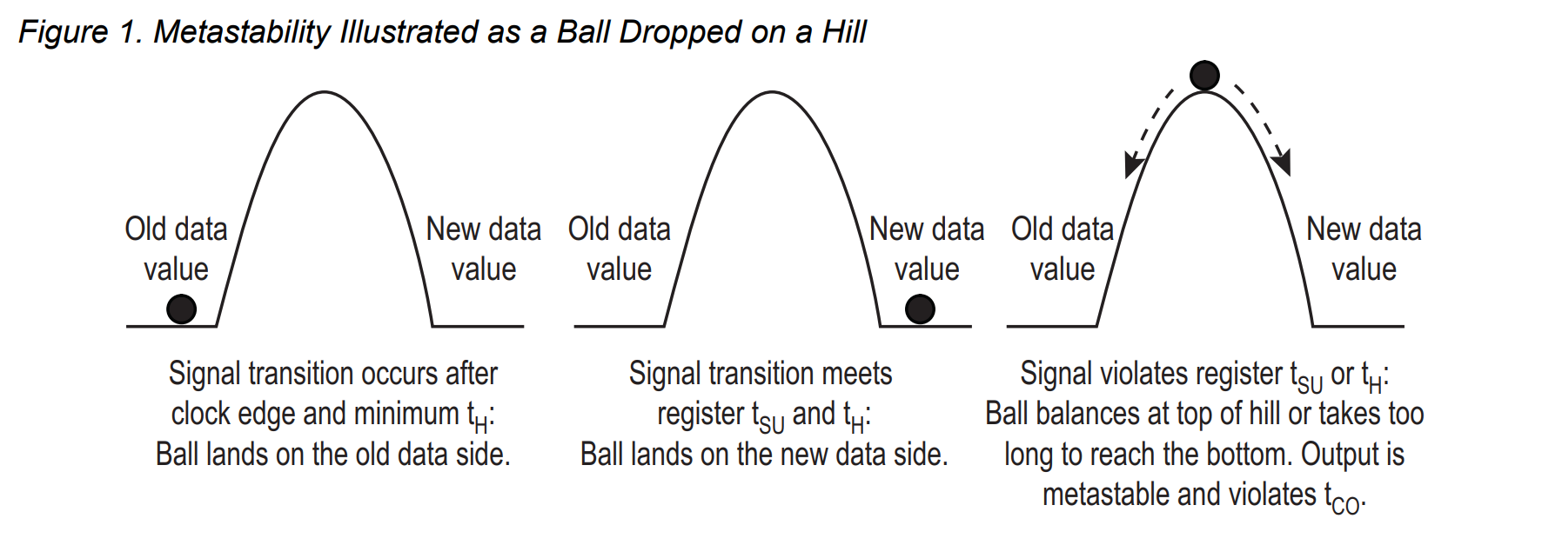
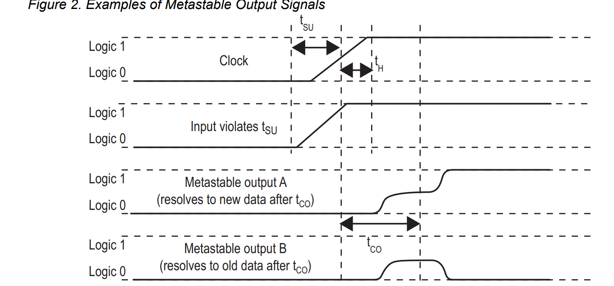

- The first register in the new clock domain acts as a synchronization register.
- The registers in the chain are all clocked by the same or phase-related clocks
- The first register in the chain is driven from an unrelated clock domain, or asynchronously
- Each register fans out to only one register, except the last register in the chain
- To minimize the failures due to metastability in asynchronous signal transfers, circuit designers typically use a sequence of registers (a synchronization register chain or synchronizer) in the destination clock domain to resynchronize the signal to the new clock domain
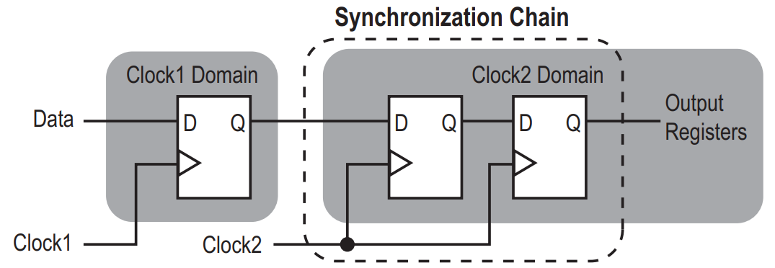

- Note that any asynchronous input signals, or signals that transfer between unrelated clock domains, can transition at any point relative to the clock edge of the capturing register. Therefore the designer cannot predict the sequence of a signal’s transitions or the number of destination clock edges until the data transitions

- If you are switching the control signal from one clock domain to the other, use a d flip flop. If you are sending a data bus, use DCFIFO.
- MTBF, due to metastability provides an estimate of the average time between instances when metastability could cause a design failure.

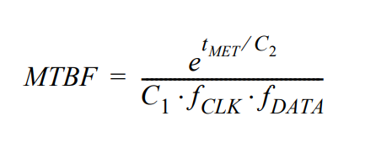
- fCLK: is the clock frequency of the clock domain receiving the asynchronous signa
- fDATA: is the toggling frequency of the asynchronous input data signal
- tMET : metastability settling time
- tCO: he time it takes for data at a register's input to appear at its output after a clock edge

- The C1 and C2 constants depend on the device process and operating conditions.
- tMET for a synchronization chain is the sum of the output timing slacks for each register in the chain
- The failure rate for a synchronizer is 1/MTBF
- The overall design MTBF can be determined by the MTBF of each synchronizer chain in the design.
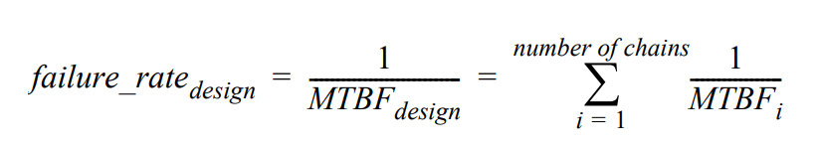

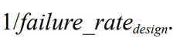
- The design metastability MTBF is

